BOOKIT 🡺 Travelling Experience:

Home Page:

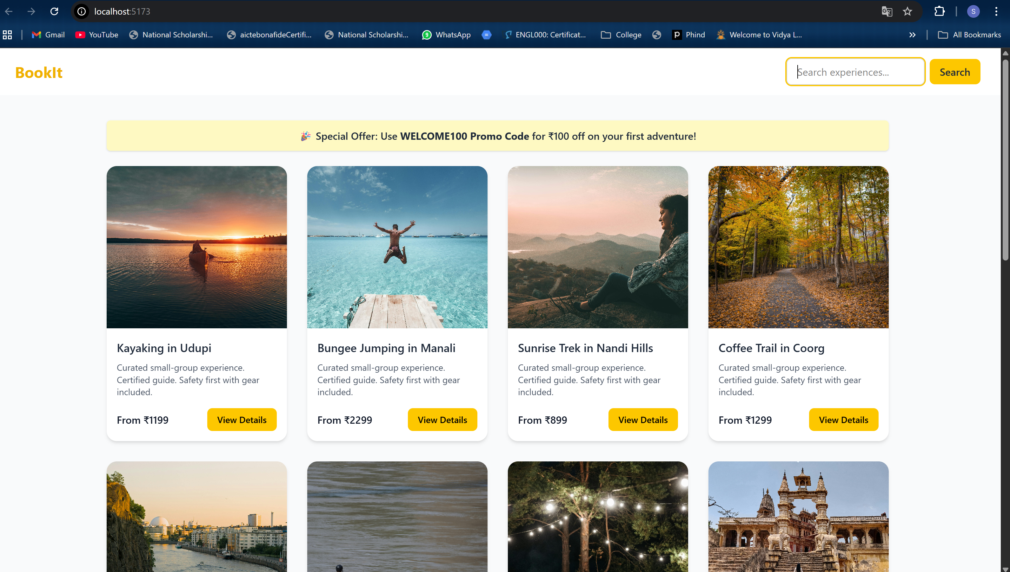

I implemented Search Functionality

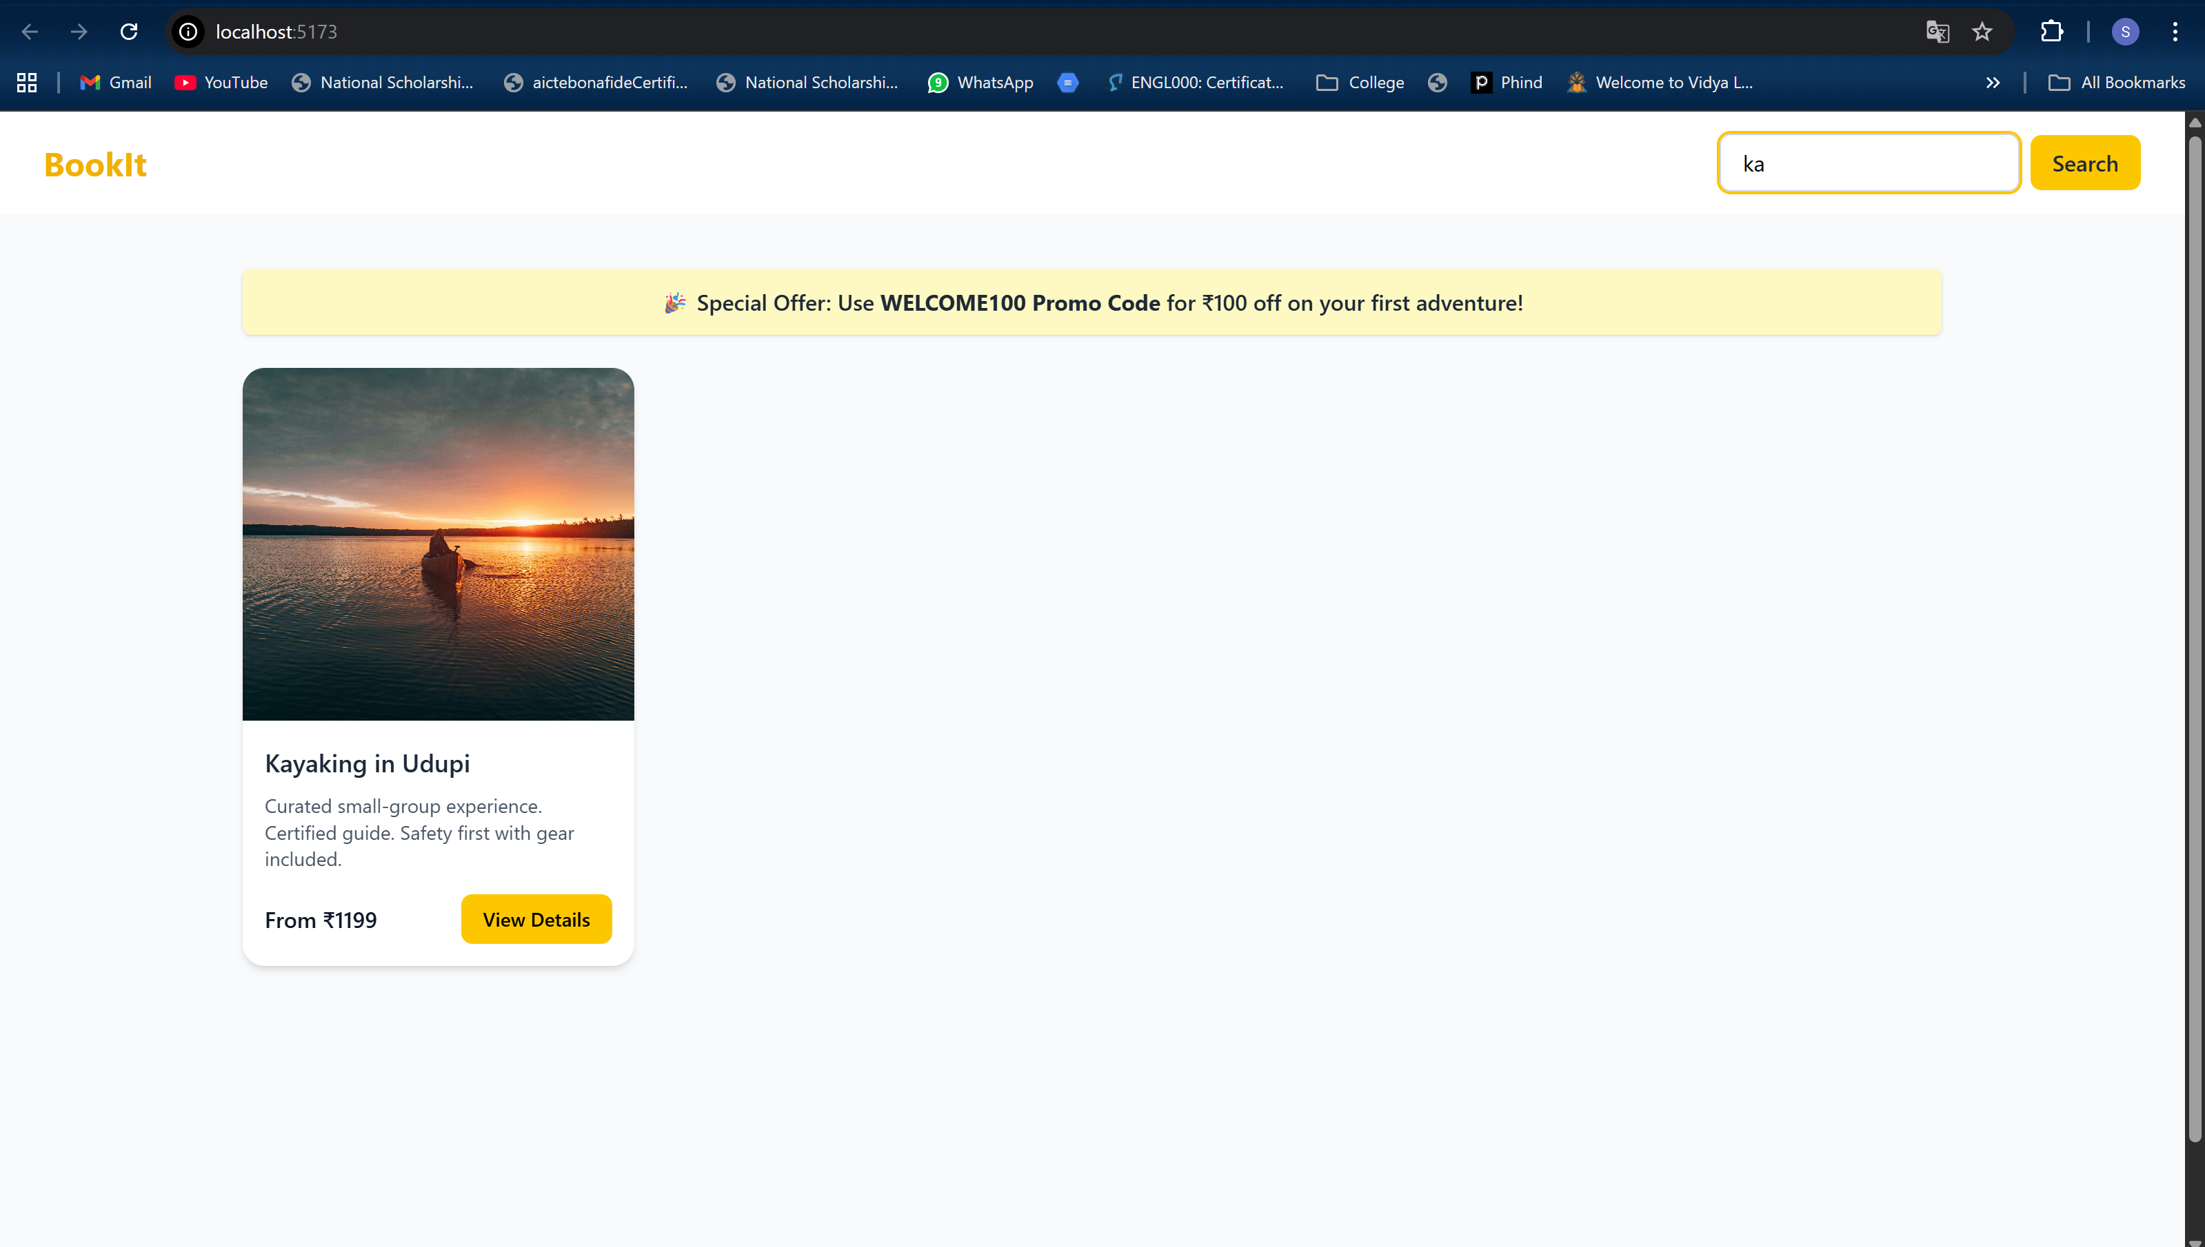

Here is the detail page and here the user have a choice to choose date and time and the payment details along with choosing multiple bookings

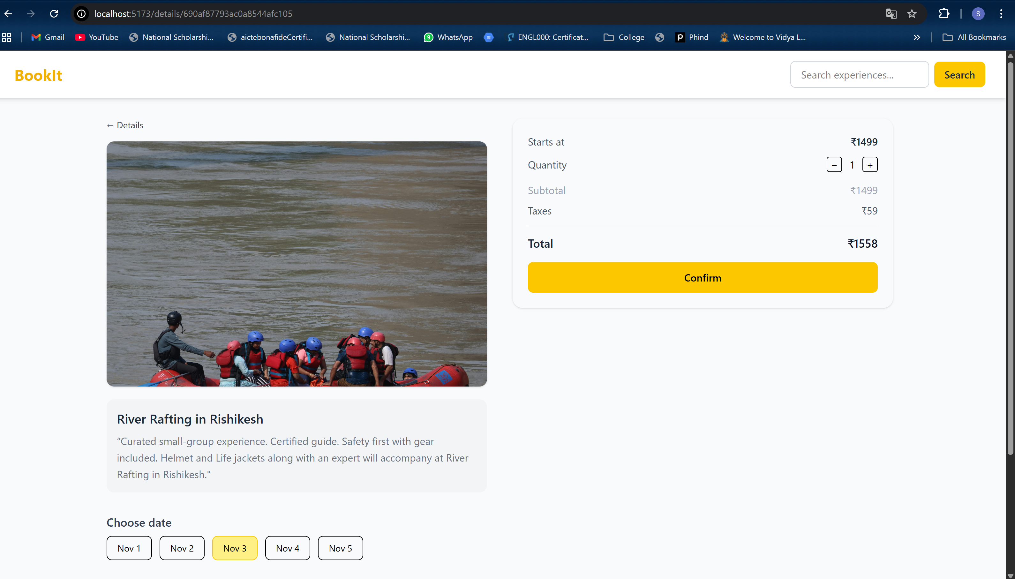

After selecting click on confirm

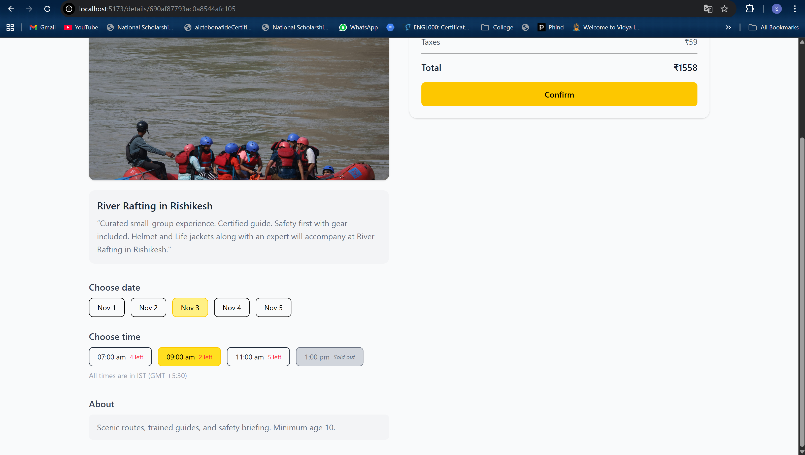

Here is the checkout page where we have to give our details and there is a option to add Promo code which is like discount and In my project I have given welcome100.it offer 100rs discount .

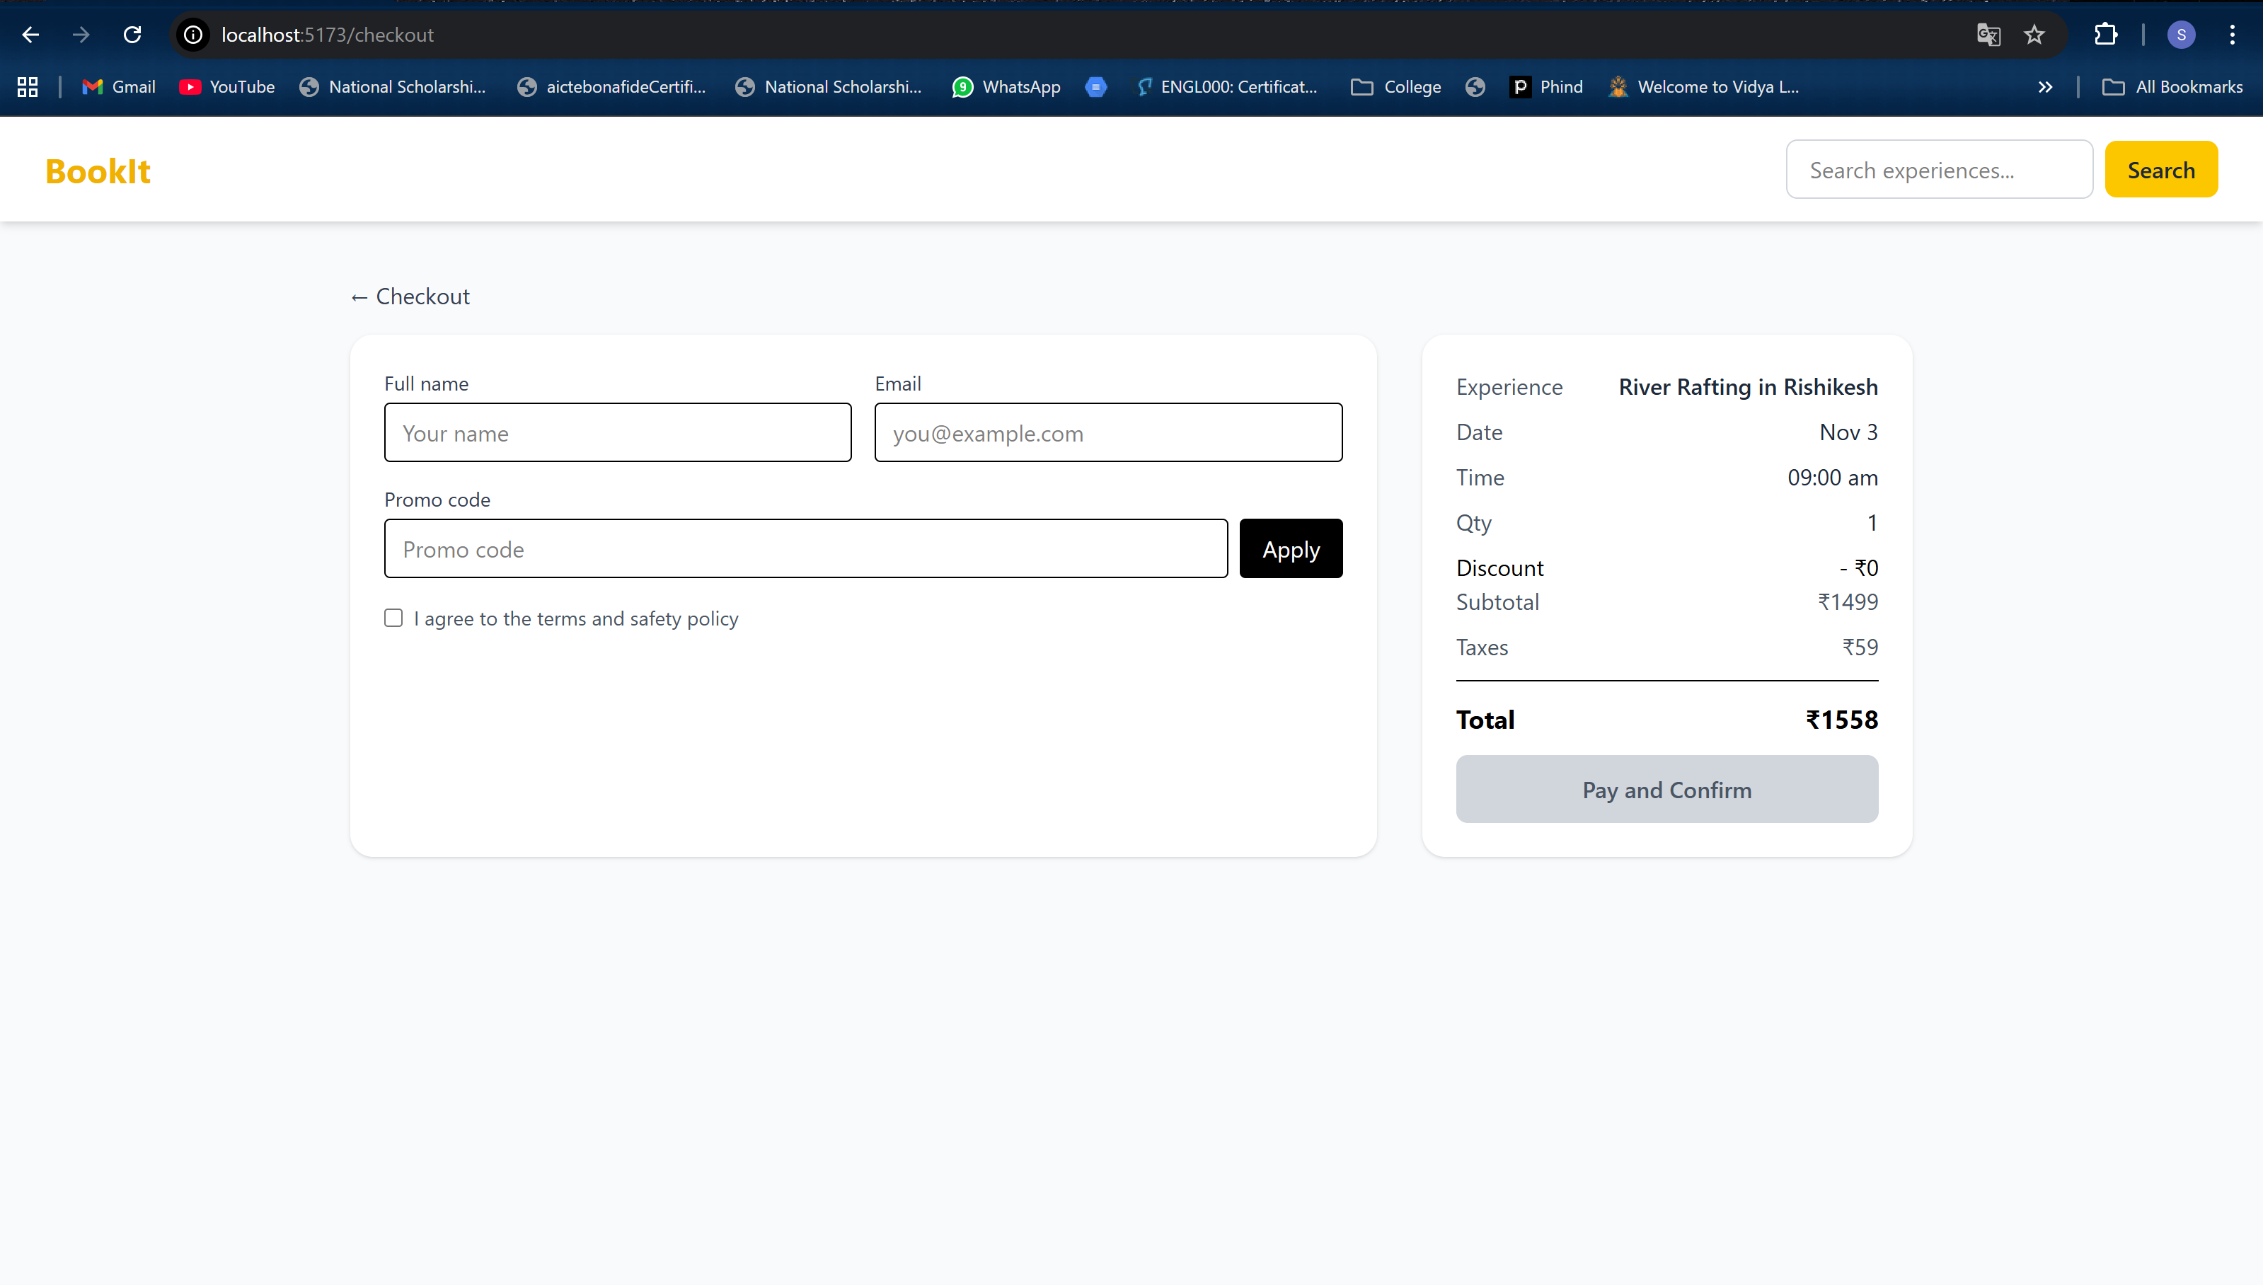

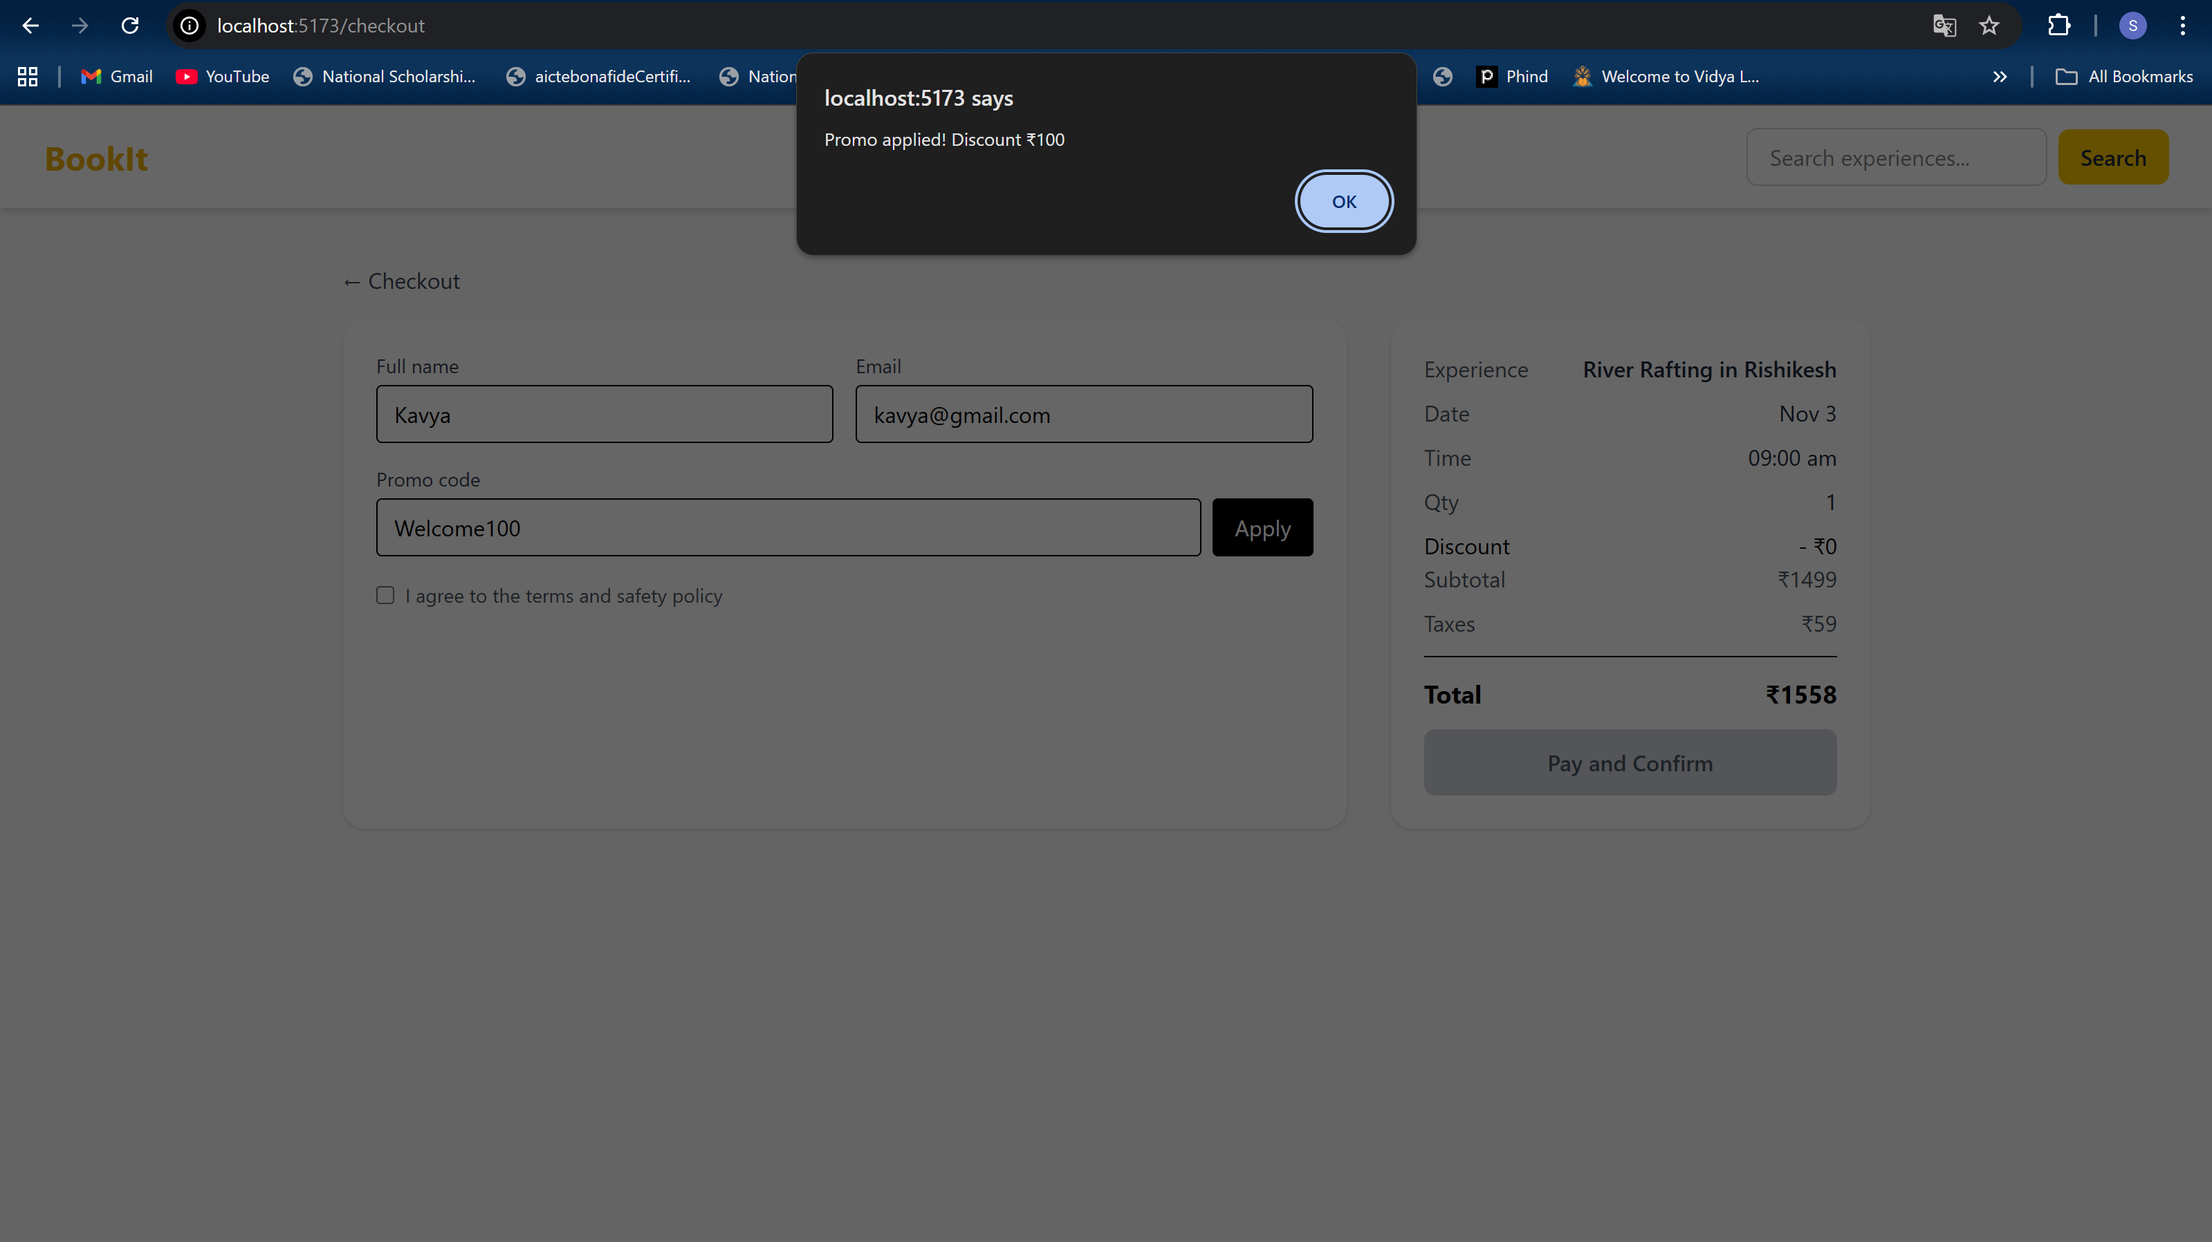

After accepting terms and conditions , click on Pay and Confirm

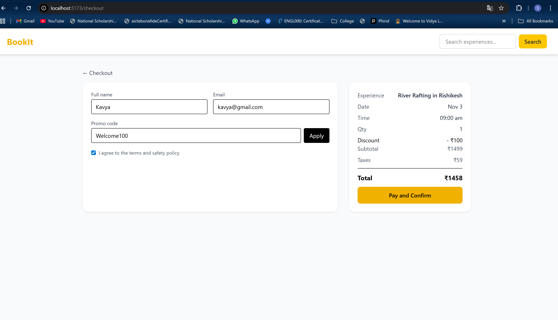

Booking is confirmed.

